**EXPERIMENT 12:**

**AIM:**

* Create a table with attributes students and marks.
* Insert values into the table.
* Create a procedure, and fetch the marks of given id using a cursor.
* Create a procedure, and fetch the highest marks using a cursor.

**SOLUTION:**

CREATE TABLE curs(id int, marks int);

INSERT INTO curs (id,marks)values(1, 30),(2, 40), (3, 50), (5, 60), (6, 70);

DELIMITER \\

CREATE PROCEDURE cur_marks(id1 int)

BEGIN

DECLARE m1 int;

DECLARE curl CURSOR FOR SELECT marks FROM curs WHERE id = id1;

OPEN curl;

FETCH curl INTO m1;

SELECT m1;

CLOSE curl;

END \\

DELIMITER ;

CALL cur_marks(2);

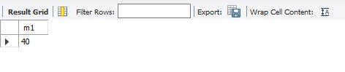

DELIMITER \\

CREATE PROCEDURE cur_mark1()

BEGIN

DECLARE m1 int;

DECLARE curl CURSOR FOR SELECT max(marks) FROM curs;

OPEN curl;

FETCH curl INTO m1;

SELECT m1;

CLOSE curl;

END \\

DELIMITER ;

CALL cur_mark1();

